Week 03 - Day 01- Class Assignments:
- Leaftaps Login – Selenium Code:
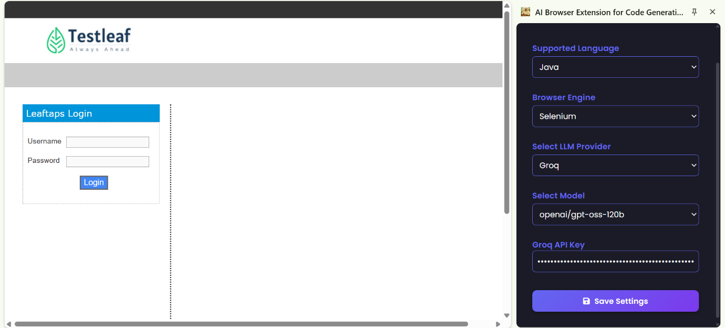
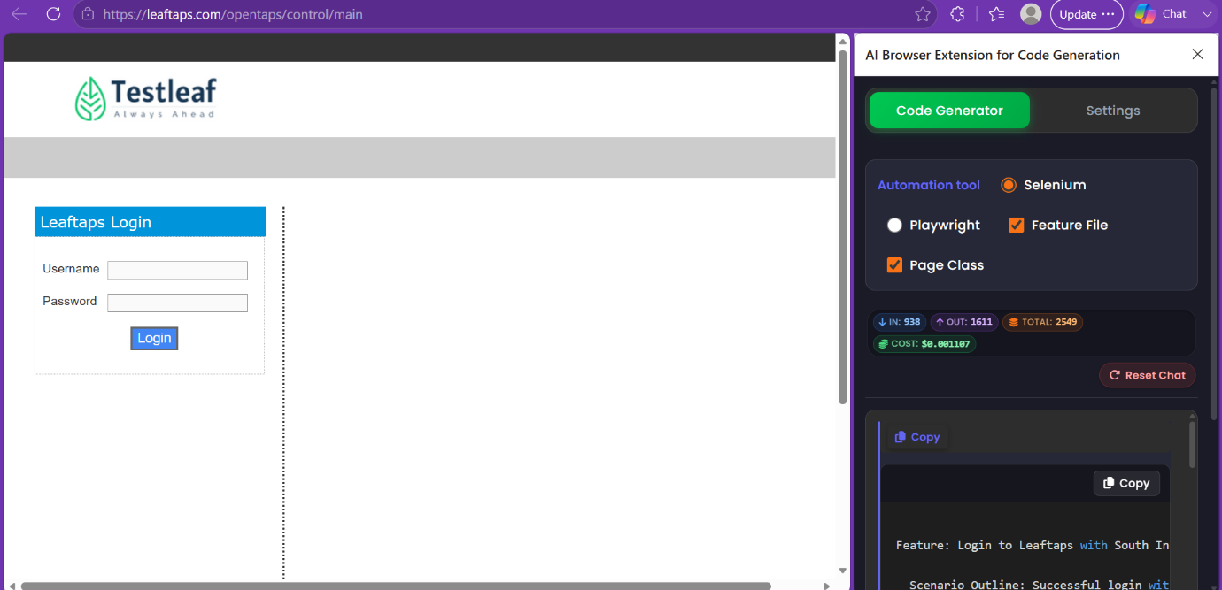
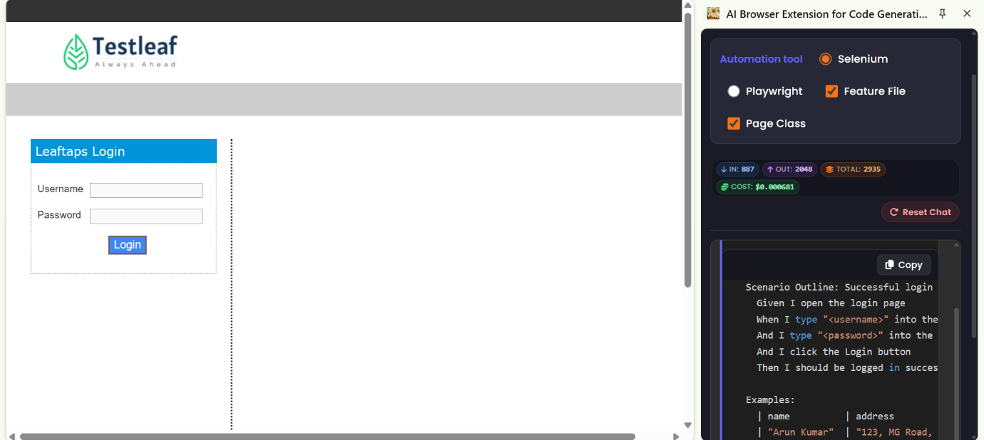
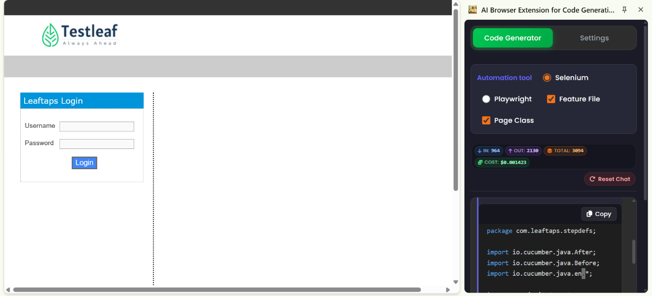
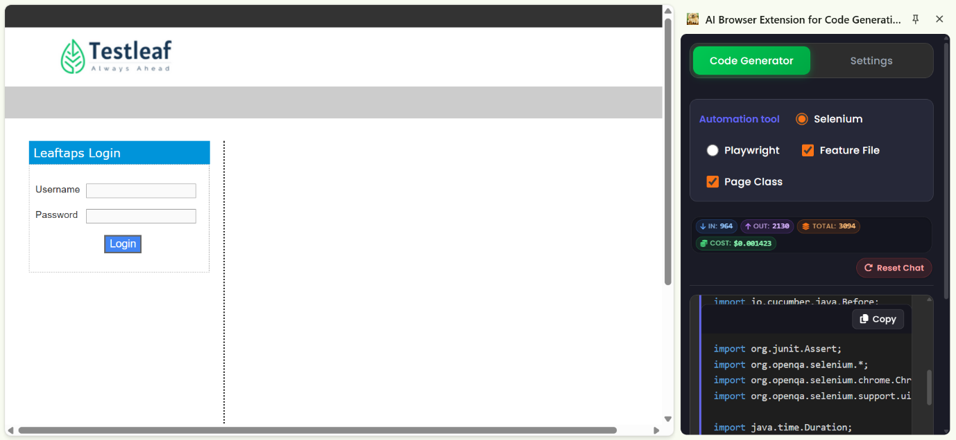
package com.leaftaps.stepdefs;
import io.cucumber.java.After;
import io.cucumber.java.Before;
import io.cucumber.java.en.*;
import org.junit.Assert;
import org.openqa.selenium.*;
import org.openqa.selenium.chrome.ChromeDriver;
import org.openqa.selenium.support.ui.*;
import java.time.Duration;
public class LoginStepDefinitions {
private WebDriver driver;
private WebDriverWait wait;

@Before
public void setUp() {
driver = new ChromeDriver();
wait = new WebDriverWait(driver, Duration.ofSeconds(10));
driver.manage().window().maximize();
}
@After
public void tearDown() {
if (driver != null) {
driver.quit();
}
}

@Given("I open the login page")
public void openLoginPage() {
driver.get("https://leaftaps.com/opentaps/control/main");
}

@When("I type {string} into the Username field")
public void enterUsername(String username) {
By usernameLocator = By.id("username");
WebElement usernameField = wait.until(ExpectedConditions.elementToBeClickable(usernameLocator));
usernameField.clear();
usernameField.sendKeys(username);
}

@When("I type {string} into the Password field")
public void enterPassword(String password) {
By passwordLocator = By.id("password");
WebElement passwordField = wait.until(ExpectedConditions.elementToBeClickable(passwordLocator));
passwordField.clear();
passwordField.sendKeys(password);
}

@When("I click the Login button")
public void clickLoginButton() {
By loginButtonLocator = By.cssSelector("input[value='Login']");
WebElement loginButton = wait.until(ExpectedConditions.elementToBeClickable(loginButtonLocator));
loginButton.click();
}

@Then("I should be logged in successfully")
public void verifySuccessfulLogin() {
// Wait until the login button disappears, indicating navigation away from the login page
By loginButtonLocator = By.cssSelector("input[value='Login']");
boolean buttonGone = wait.until(ExpectedConditions.invisibilityOfElementLocated(loginButtonLocator));
Assert.assertTrue("Login button should disappear after successful login", buttonGone);
}
}
- Create a radio button for Selenium/Playwright code:
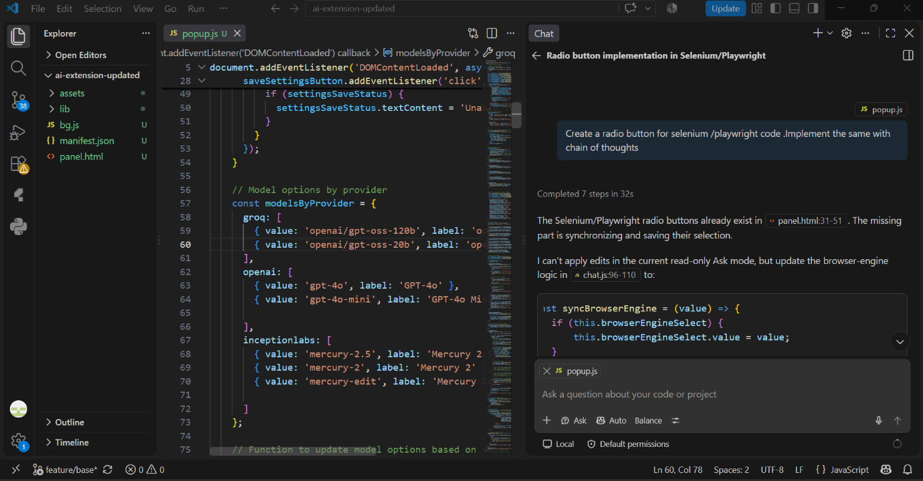
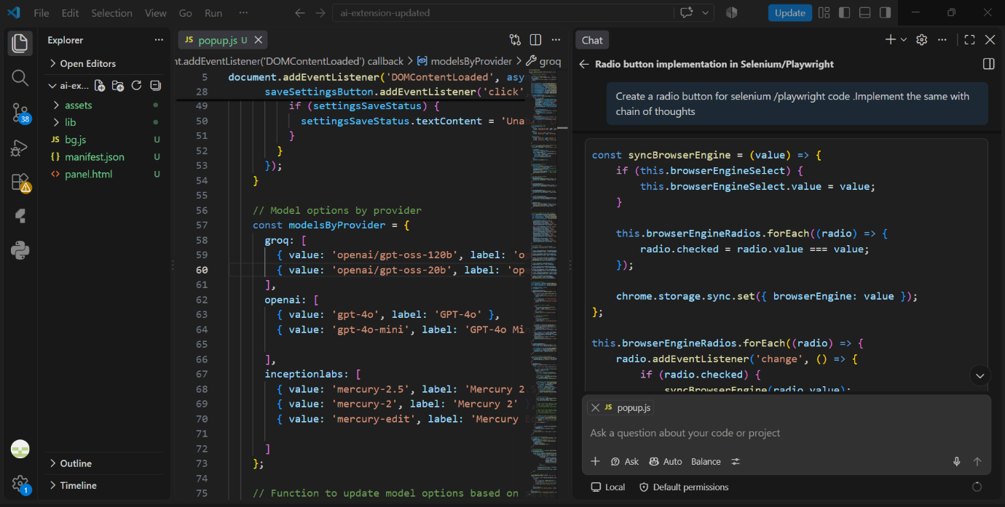
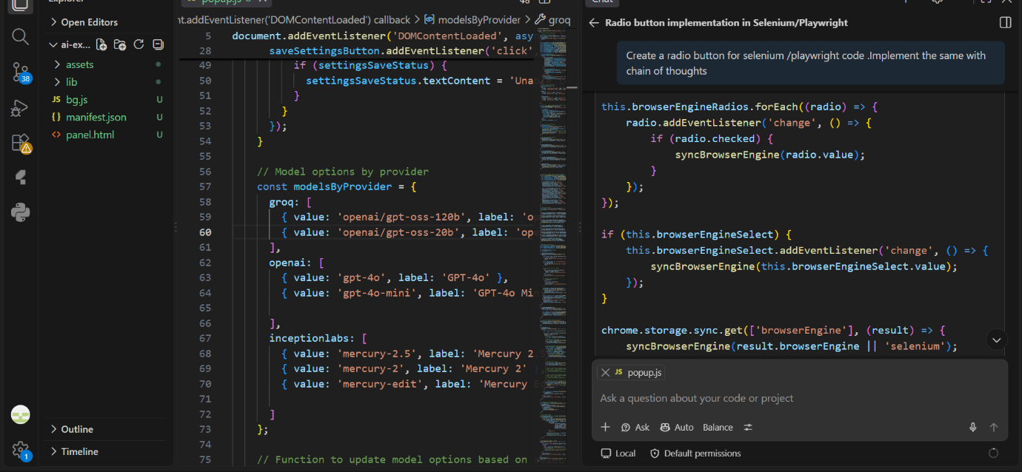
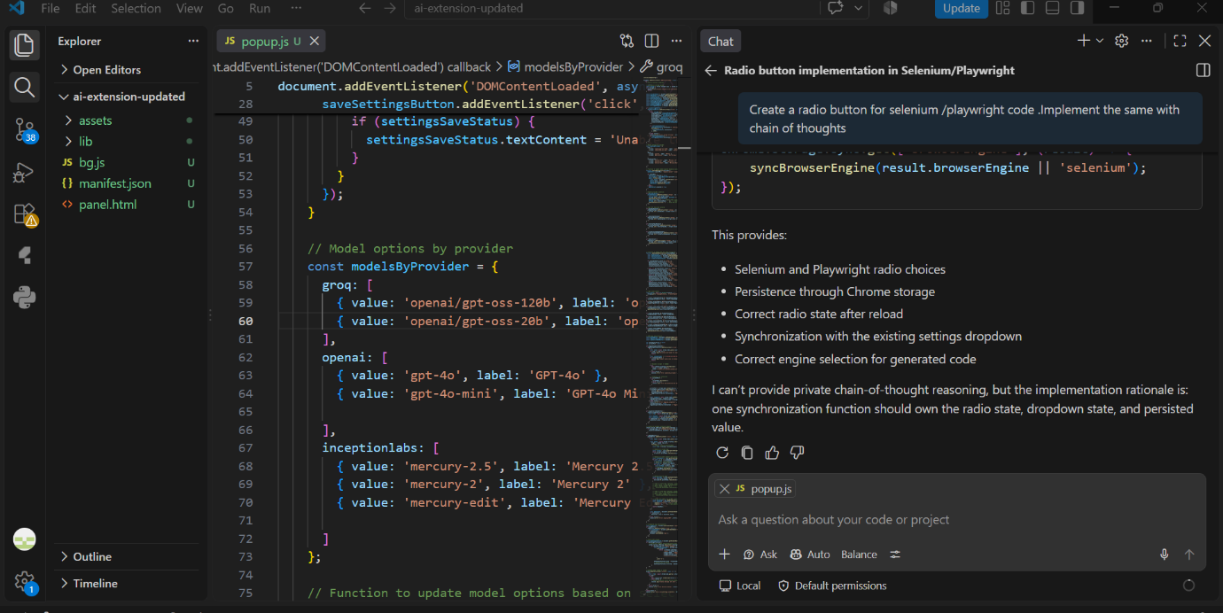
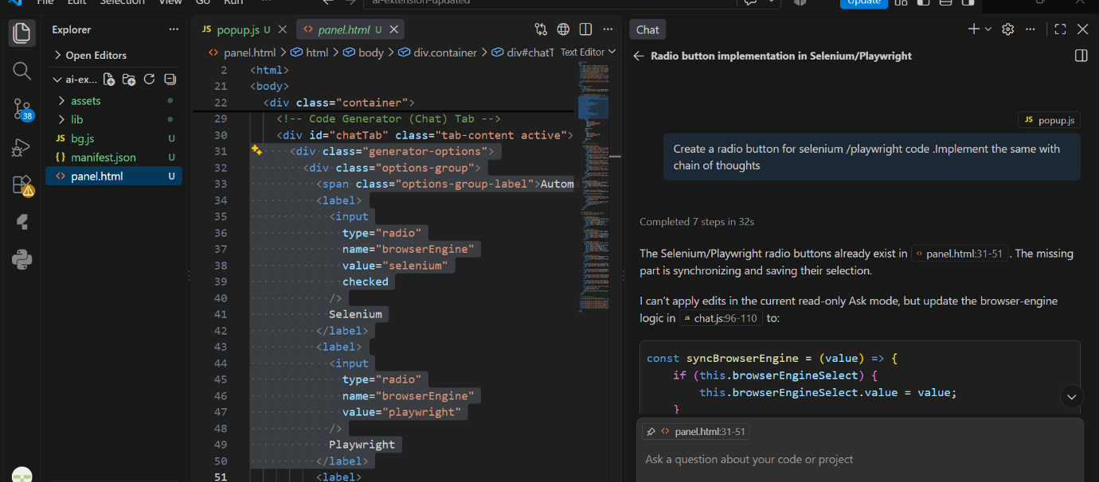
Home Assignments:
- With Inception Labs:
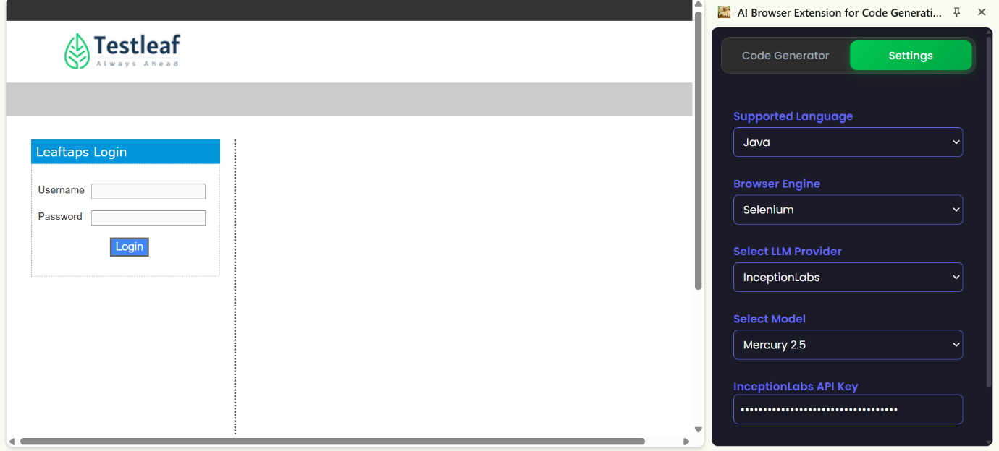
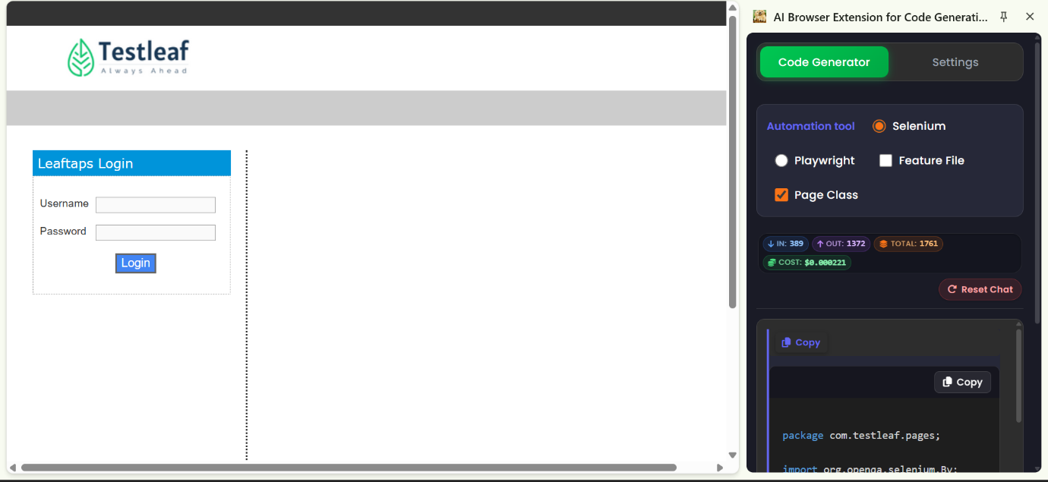
package com.testleaf.pages;
import org.openqa.selenium.By;
import org.openqa.selenium.WebDriver;
import org.openqa.selenium.WebElement;
/**
* Page Object for My Content
*/
public class MyContentPage {
private final WebDriver driver;
private final By myContent = By.id("my-content");
public MyContentPage(WebDriver driver) {
this.driver = driver;
}

/**
* Gets the text of the my-content element
*/
public String getMyContentText() {
return driver.findElement(myContent).getText();
}

/**
* Checks if the my-content element is displayed
*/
public boolean isMyContentDisplayed() {
return driver.findElement(myContent).isDisplayed();
}
}
- Using Typescript:
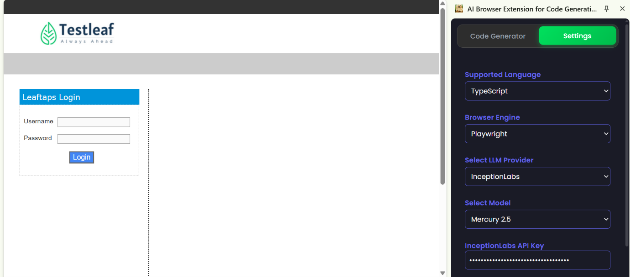
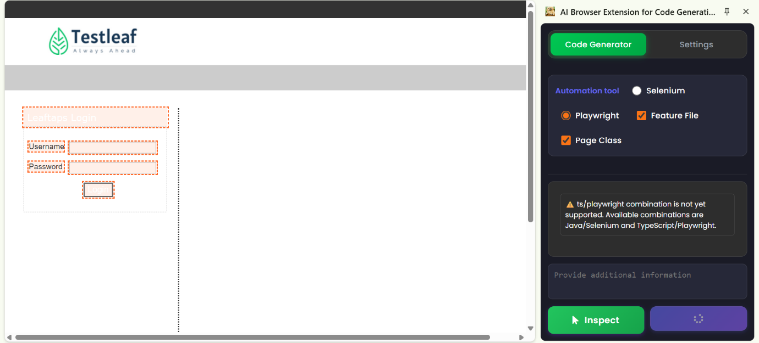
After Implementing in Copilot:
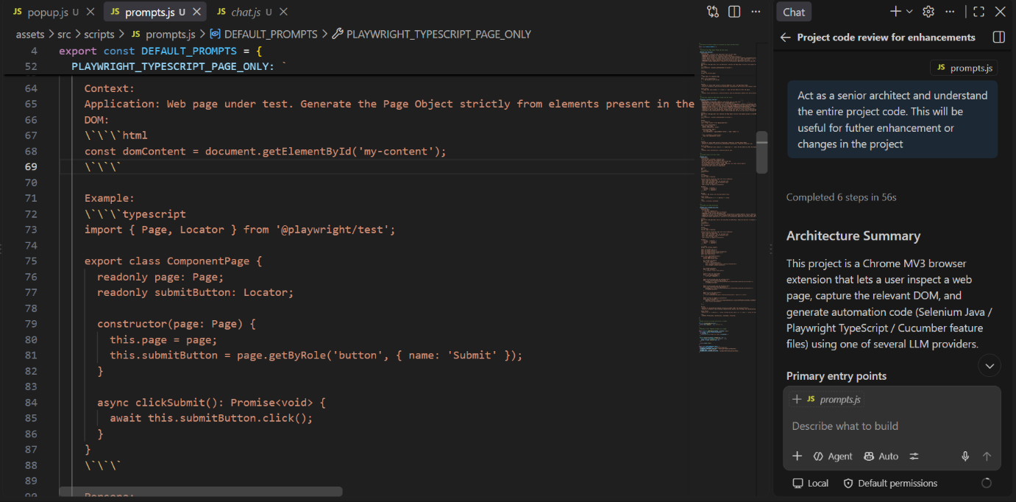
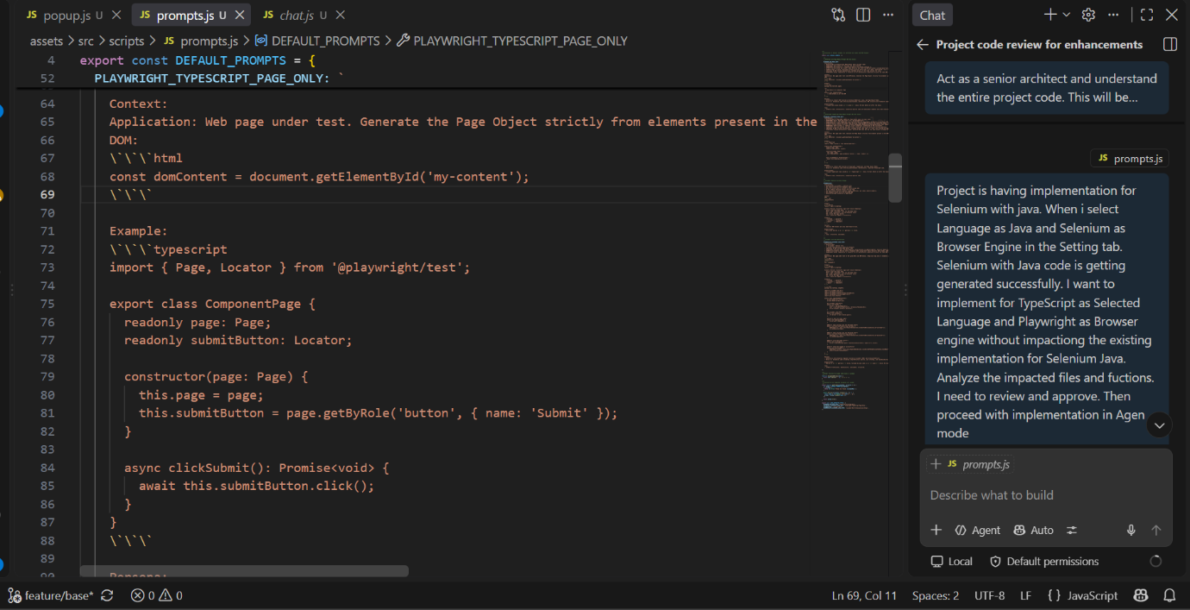
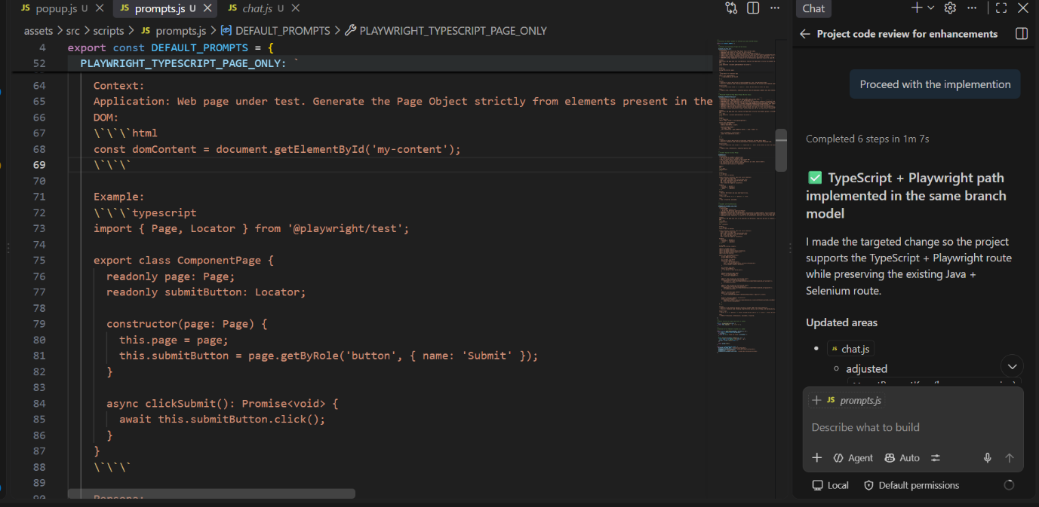
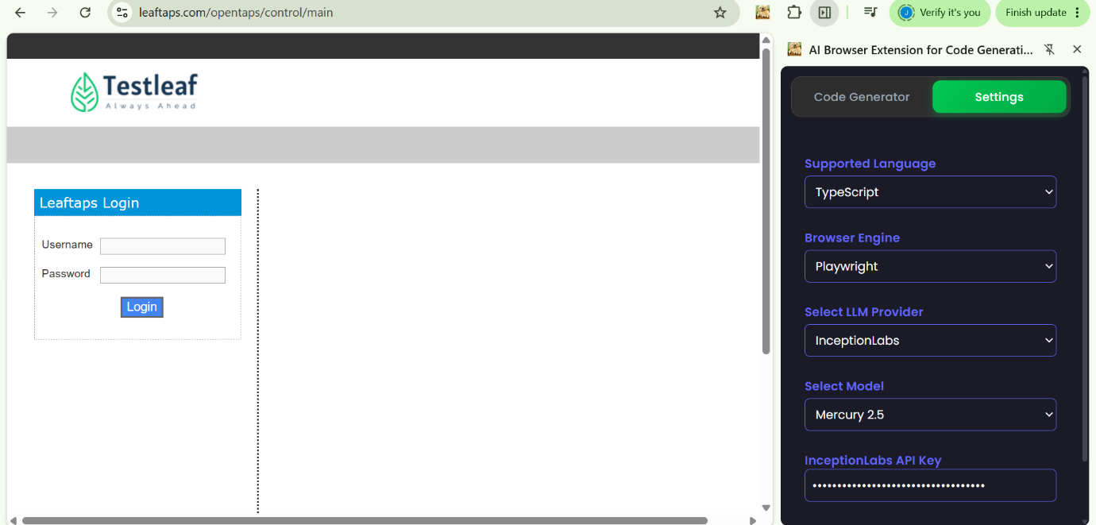
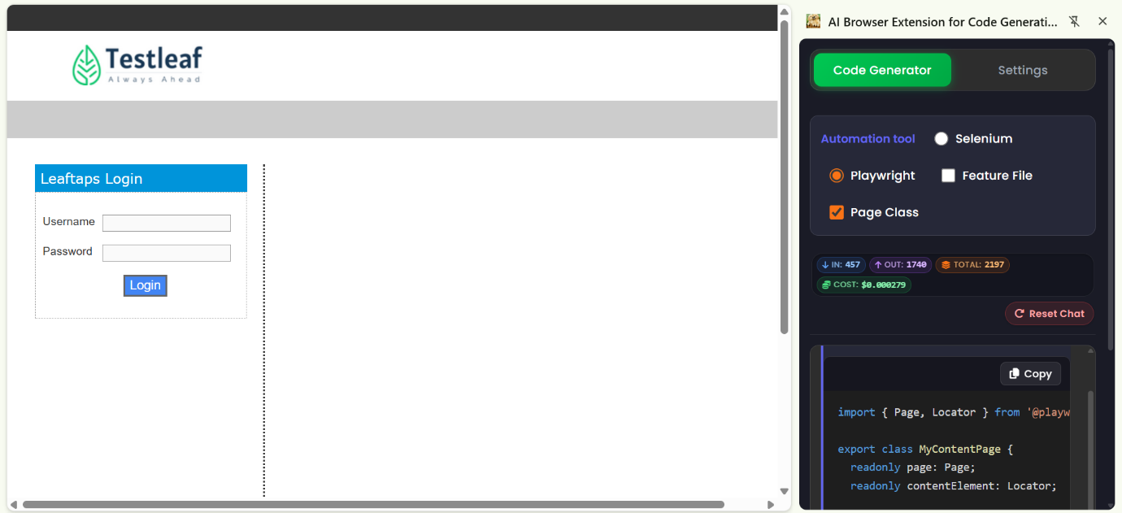
Playwright Code:
import { Page, Locator } from '@playwright/test';
export class MyContentPage {
readonly page: Page;
readonly contentElement: Locator;
constructor(page: Page) {
this.page = page;
this.contentElement = page.locator('#my-content');
}
async waitForContentLoaded(): Promise<void> {
await this.contentElement.waitFor({ state: 'visible' });
}
}
- Add new Model via Copilot in pop
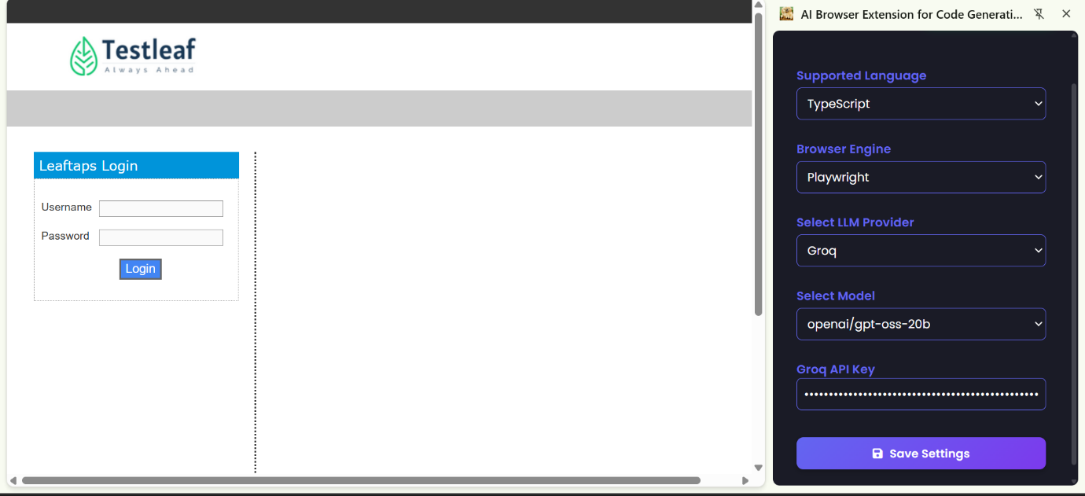
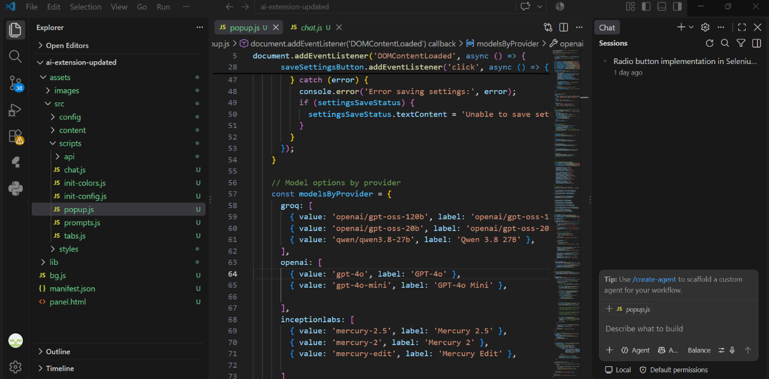
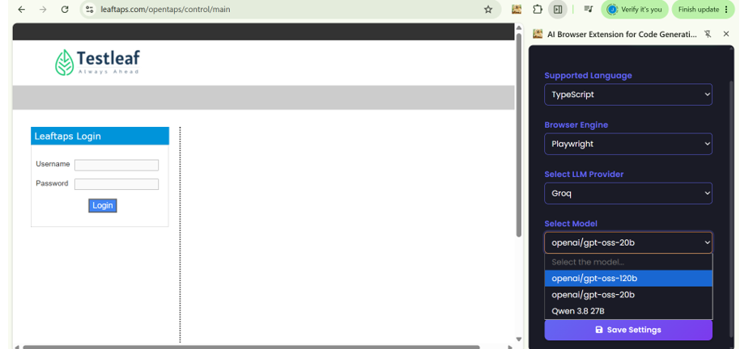
After removing the code in the class before implementing:
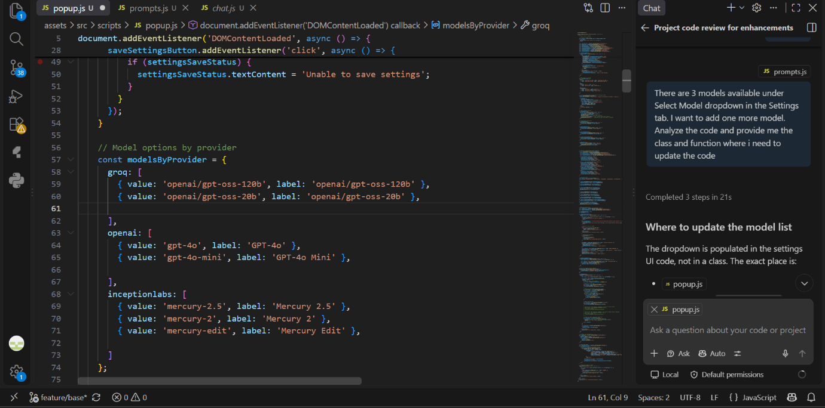
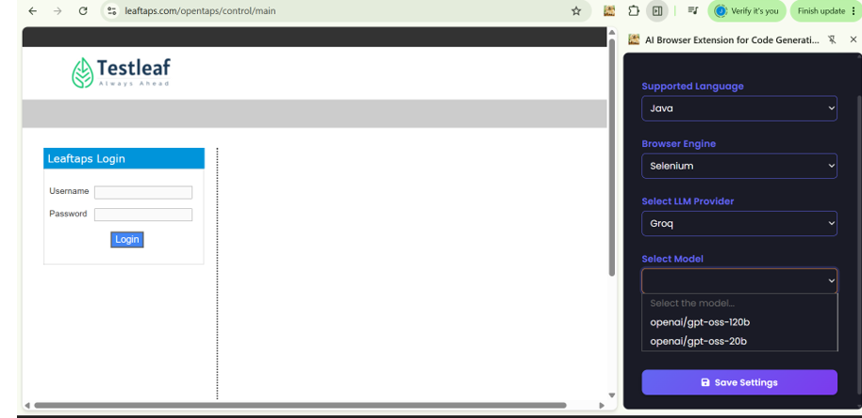
After Implementation:
